Chapter 18, Solution 21.

Using Parseval’s theorem,

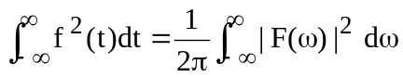

If f(t) = u(t+a) – u(t+a), then
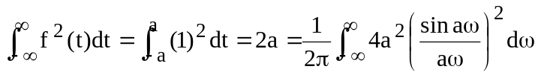
or

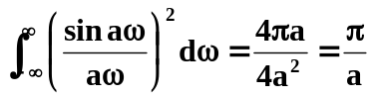 as required.

